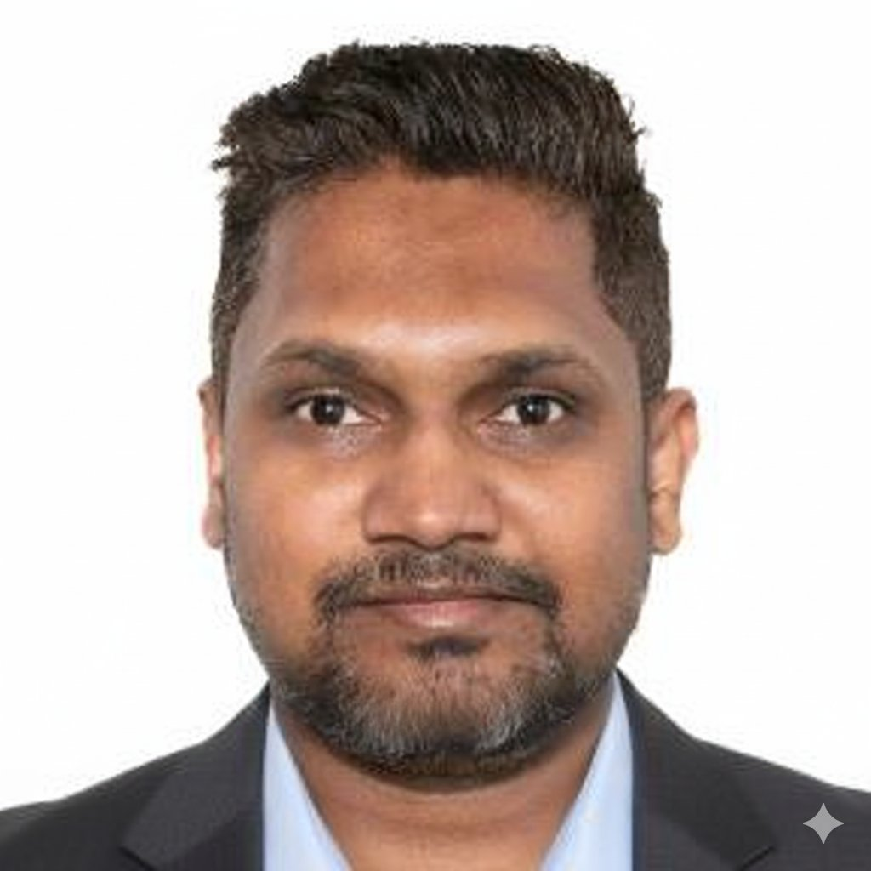  CONTACT  JLT, Dubai, UAE  +971-50-594-2463  sp.shetty@yahoo.com  VISA STATUS  Employment Visa  UAE — Transferable  CORE SKILLS  Process Automation & ITSM  ● ● ● ● ●  AI-Driven IT Operations  ● ● ● ● ●  ITIL v4 / Service Mgmt  ● ● ● ● ●  Scripting (PowerShell / API)  ● ● ● ● ●  Cloud Automation (Azure / M365)  ● ● ● ● ●  Network & Security (VLAN/VPN/DLP)  ● ● ● ● ●  Governance & Compliance  ● ● ● ● ●  VMware / Virtualisation  ● ● ● ● ●  ERP / Odoo Support  ● ● ● ● ●  Linux / Windows / macOS  ● ● ● ● ●  CERTIFICATIONS  VMware VCP 510  Dell DCSE 2010  VMware vSphere 5.0 Training  CCNA Training (2005)  Wireless Security Masterclass  Digital Marketing Diploma  EDUCATION  HSC — 2000  SDPT Pre-Univ. College, Mangalore  SSC — 1998  SDPT High School, Mangalore  LANGUAGES  English (Fluent)  Hindi (Fluent)  Tulu (Native)  Kannada (Proficient)  PERSONAL  DOB: 11 Feb 1983  Nationality: Indian | SHIVAPRASAD SHETTY  IT Manager | IT Director | IT Operations Manager | 19+ Yrs UAE Experience | Cloud | Cybersecurity | Microsoft 365 | AI-Enabled Digital Transformation  PROFESSIONAL SUMMARY  Senior IT Leader with 20+ years of experience across UAE and India, building and managing high-performing IT environments that drive business growth and digital transformation. Proven track record delivering multi-site infrastructure across Oil & Gas, Media, and Enterprise sectors spanning Dubai, Abu Dhabi, London, Mumbai, and KSA. Deep expertise in IT operations management, cloud and hybrid infrastructure, cybersecurity, AI-enabled automation, and ITIL-aligned service delivery. Adept at leading teams, managing vendors, and aligning IT strategy with business objectives.  20+ Years Experience • 300+ Users Managed • 6 Countries Supported • 30–40% Faster Resolution  PROFESSIONAL EXPERIENCE  Founder | IT Knowledge Platform  FixieIT.com | Jul 2025 – Present  - Founded and manage Fixie IT, an independent technology knowledge platform focused on simplifying IT support, cybersecurity, cloud technologies, Microsoft 365, AI tools, and workplace productivity.  - Create and publish practical IT troubleshooting guides and technology resources covering Microsoft 365, networking, cloud infrastructure, cybersecurity, backup, and end-user support.  - Manage website operations, content strategy, SEO, and digital presence; explore emerging technologies including AI, automation, and modern workplace solutions.  Senior IT Manager | IT Operations | Cloud | Cybersecurity | Digital Transformation  VSP (Petroleum, Oil Terminal & Shipping), Dubai, UAE | Jul 2024 – Jul 2025  - Championed AI-powered automation initiatives that reduced manual IT workloads and improved team throughput across operational systems.  - Reduced helpdesk resolution time by 30% through process automation and streamlined, rule-based ticket-triage workflows.  - Administered Microsoft 365 and cloud services; improved scalability, availability and disaster-recovery posture through automated provisioning and monitoring.  - Provided Level 2/3 ERP support for Odoo (Finance, HR, Accounts), automating recurring workflows to improve module adoption.  - Embedded SOPHOS endpoint protection and DLP policies across all systems — achieved zero critical incidents, aligned to security and audit requirements.  - Sustained 99%+ uptime via proactive monitoring across multi-site networks for a petroleum trading, shipping and oil-terminal operation.  Senior Systems Administrator  ITP Media Group, Dubai, UAE (300+ users • 6 countries) | Mar 2015 – Jul 2024  - Delivered IT operations across a multi-country, multi-entity environment (UAE, UK, India, Qatar, KSA) — a shared-services-style model — with near-zero downtime over 9 years.  - Automated Active Directory user lifecycle (provisioning, group policy, offboarding) through scripting and GPO, achieving zero-error compliance.  - Built GPO-driven automated software deployments, significantly reducing recurring support tickets.  - Deployed and managed Citrix Workspace, enabling seamless remote-work continuity during and post-COVID.  - Owned SOPHOS firewall management — gateway security, VPN, traffic monitoring and remote access for global teams; designed secure VLAN segmentation.  - Managed ZOHO Suite, Meraki, IP Phones and antivirus/endpoint servers across the full estate.  Assistant Manager — IT Operations  Fractal Analytics, Mumbai, India | Mar 2013 – Mar 2014  - Deployed ZOHO ManageEngine Plus (ITIL-aligned ITSM) — cut average ticket-resolution time by 40% through workflow automation.  - Led a 5-person IT team through ISO and PCI-DSS certification audits with zero non-conformances — embedding governance, logging and audit readiness.  - Operated within a data/analytics enterprise: managed Active Directory, Google Workspace, Hadoop servers and network infrastructure.  - Built an automated knowledge base (video tutorials + GPO deployment), reducing recurring support tickets.  IT Services Administrator  Servcorp, Abu Dhabi, UAE (50+ enterprise clients) | Dec 2010 – Nov 2011  - Supported marquee financial-services clients (JP Morgan, Bank of America, Bank of Montreal) and aviation within a shared-services delivery model.  - Administered Windows Servers, Active Directory, MS Exchange, DHCP and Layer-3 switching with custom VLANs for 50+ clients; delivered remote support.  Helpdesk Engineer  Emirates Computers (Dell Gold Partner), Abu Dhabi, UAE | Aug 2008 – Dec 2010  - UAE point of contact for Dell support escalations; monitored SLAs, service quality and client satisfaction across engagements.  - Built an in-house VMware virtualisation lab for training and testing, reducing reliance on production environments.  System Support Engineer  Hostway Solutions Pvt. Ltd, Mumbai, India | Jul 2006 – Jul 2008  - Independently managed all IT operations — servers, desktops, VOIP (150 users), and BACULA backup automation across Linux/Windows systems.  Assistant Systems Engineer  Directi Pvt. Ltd, Mumbai, India | Jun 2004 – Jul 2006  - Configured RAID arrays, staged servers in data centres, and maintained full IT inventory; managed OS and email-client deployments.  TECHNICAL SKILLS & TOOLS  Automation & ITSM: ZOHO ManageEngine (ITIL), Net Helpdesk, process automation, AI-driven tooling, GPO automation, ticket-triage workflows  Scripting & Integration: PowerShell, Group Policy scripting, API-based system integration, automated provisioning  Cloud & Identity: Microsoft 365 Admin, Azure AD, Google Workspace, cloud migration strategy  Infrastructure & Virtualisation: Windows Server, Active Directory, DHCP/DNS, VMware vSphere, Hyper-V, Citrix Workspace  Network & Security: SOPHOS Firewall & Endpoint, DLP, Cisco Meraki, VLAN/VPN/SD-WAN, IP Phones, CCTV/Biometrics  Platforms & Other: Linux / Windows / macOS, Odoo ERP, Hadoop (data infra), BACULA, RAID, Disaster Recovery  CERTIFICATIONS & PROFESSIONAL TRAINING  - VMware Certified Professional 510 (VCP 510) • Dell Certified Systems Expert (DCSE 2010)  - VMware vSphere 5.0 — Install, Configure, Manage (2012) • CCNA Training (2005)  - Master Class in Wireless Security & Ethical Hacking, Dubai (2016)  - Digital Marketing Diploma, Shaw Academy UK (2015) • Computer Hardware & Networking Diploma (2003)

